FishPass Monthly Update
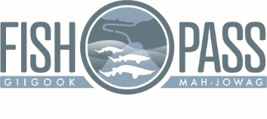
Dear partners and stakeholders:

On behalf of the FishPass team, I am pleased to provide to you our December FishPass update. Please distribute the update as you see fit.

Engineering Design Update:
- 20 December. The designer of record, AECOM, submitted the 100% engineering design, specifications, and Basis of Design Report to the Great Lakes Fishery Commission (GLFC). Final design reviews are underway by FishPass Project Partners, U.S. Army Corps of Engineers Agency Technical Review Team, and Independent External Peer Review Team.
- The U.S. Army Corps of Engineers public notice, as required for the project application for a permit under Section 10 of the Rivers and Harbors Act of 1989 and Section 404 of the Clean Water Act, remains open for public comment until January 17, 2020. The public notice and instructions to submit a comment are available on the USACE website. Note, the public notice and comment session required for the Joint Permit Application issued by the Michigan Department of Environment, Great Lakes, and Energy (EGLE) was held on Feb. 12, 2019.
Assessment:
- No fish sampling occurred in December 2019. As part of the fish movement project the Boardman River, from the mouth to the Union St. dam, is consistently monitored on a bi-weekly basis with a mobile radio telemetry receiver. Individual fish with radio telemetry tags are located and mapped as part of this effort. See where different fish spent the holiday season in Figure 1 below.
- In December, the FishPass team was awarded a grant of approximately $141,000 USD from the Fisheries Research Program of the Great Lakes Fishery Commission for a research project: “Determining connectivity between the Boardman River, Grand Traverse Bay, and Lake Michigan proper in support of FishPass”. This project will use acoustic telemetry to document fish movement behavior. It leverages a newly deployed acoustic telemetry array that was installed in Grand Traverse Bay in November 2019 by a multi-agency collaborative looking at cisco Coregonus artedii and lake whitefish Coregonus clupeaformis ecology. The GLFC funds will be used to add additional acoustic receivers specific to FishPass objectives (Figure 2) and tag 40 common white suckers Catostomus commersonii, longnose suckers Catostomus catostomus, rainbow trout Oncorhynchus mykiss, walleye Sander vitreus, and Lake trout Salvelinus namaycush. Overall this project will expand the current fish movement studies in geographic and ecological scope.
In the News:
- FishPass Permit for Boardman River Dam Open for Public Comment (Record Eagle, 8 December 2019): https://www.record-eagle.com/news/local_news/fishpass-permit-for-boardman-river-dam-open-for-public-comment/article_e1d77fb4-15f2-11ea-a987-bb8ae65bdb62.html
- FishPass Open Houses Scheduled For Tuesday (The Ticker, 3 January 2020): https://www.traverseticker.com/news/fishpass-open-houses-scheduled-for-tuesday/
- FishPass open house coming (Record Eagle, 6 January 2020): https://www.record-eagle.com/news/local_news/fishpass-open-house-coming/article_01cc066a-2b1e-11ea-89d0-3bb417892a90.html

Upcoming Events:
- 07 January 2020 - City officials will host two open houses during which the public can interact with the FishPass team and visit information stations on (1) history of the Boardman River Restoration project; (2) FishPass designs; (3) Dam repair needs; (4) Biology and ecology of the river; (5) Social/educational elements of the project; and (6) future of the lower Boardman. The sessions will be from 10 a.m. to 12 p.m. and from 5 to 7 p.m. on Tuesday, Jan. 7, at the Governmental Center, 400 Boardman Ave., Traverse City.
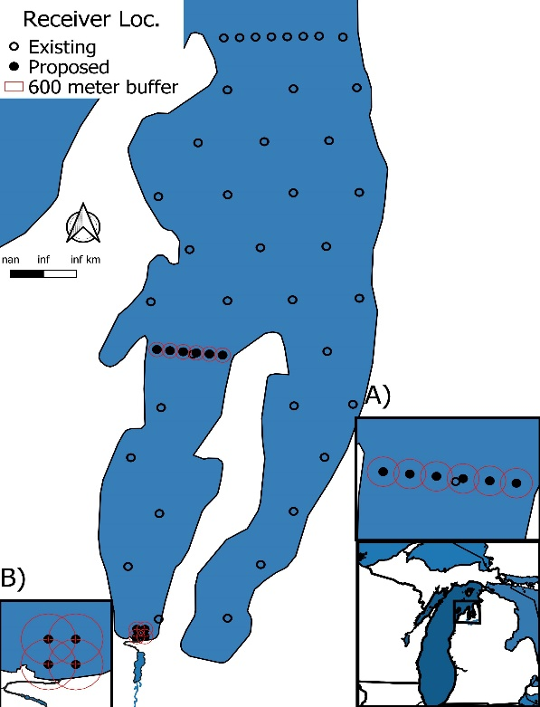
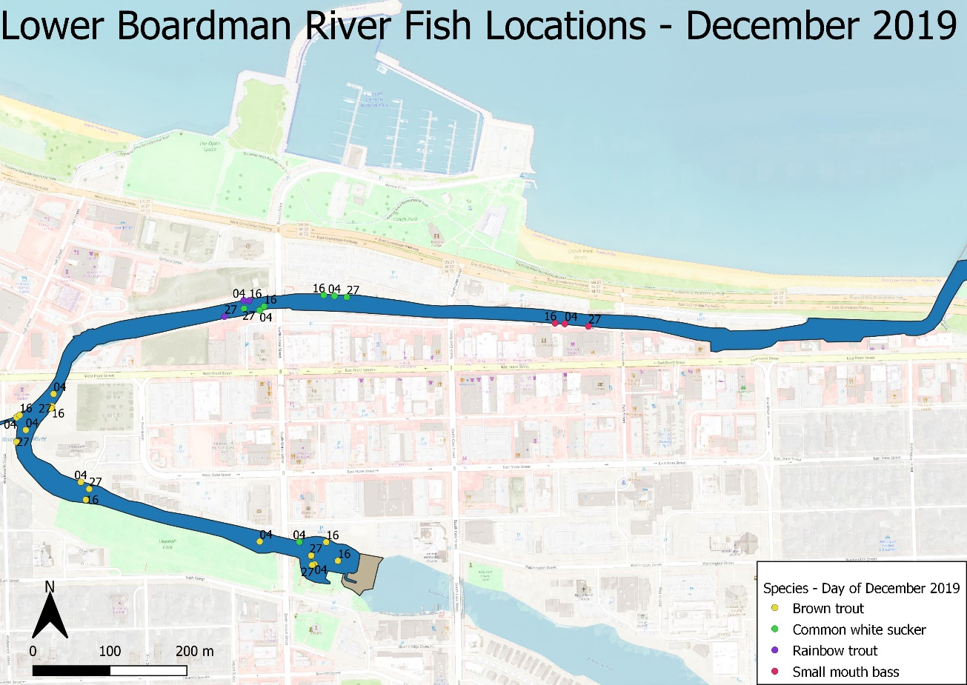
Figure 2. Grand Traverse Bay and approximate location of acoustic receivers proposed and existing receivers part of concurrent project. Frame A is West GT Bay array. Frame B is the Boardman River estuary array.
Figure 1. Fish locations by species manually located in the Boardman River in December 2019. Colors represent species, labels represent the day of December.

